**How to Send Form for Review and** **Approval?**

* 1. Any form screen (mention download the form)
* 2. Show the form filled up.
* 3. Show upload button screen and mention upload for here
* 4. Show the review and approval screen (click to review and select who to send the form for review.
* Put a note below the screenshot
* Note: A review form needs to be send again for approval kindly follow the below mentioned steps.
* A Downloaded and filled form when uploaded can directly be send for approval (without review)
* Screen Shot Show Approve button clicked and in people write call select the person who will approve.

# How to Upload a Form for Review (By Ship)?

Step 1: login the application, click the sign in button.

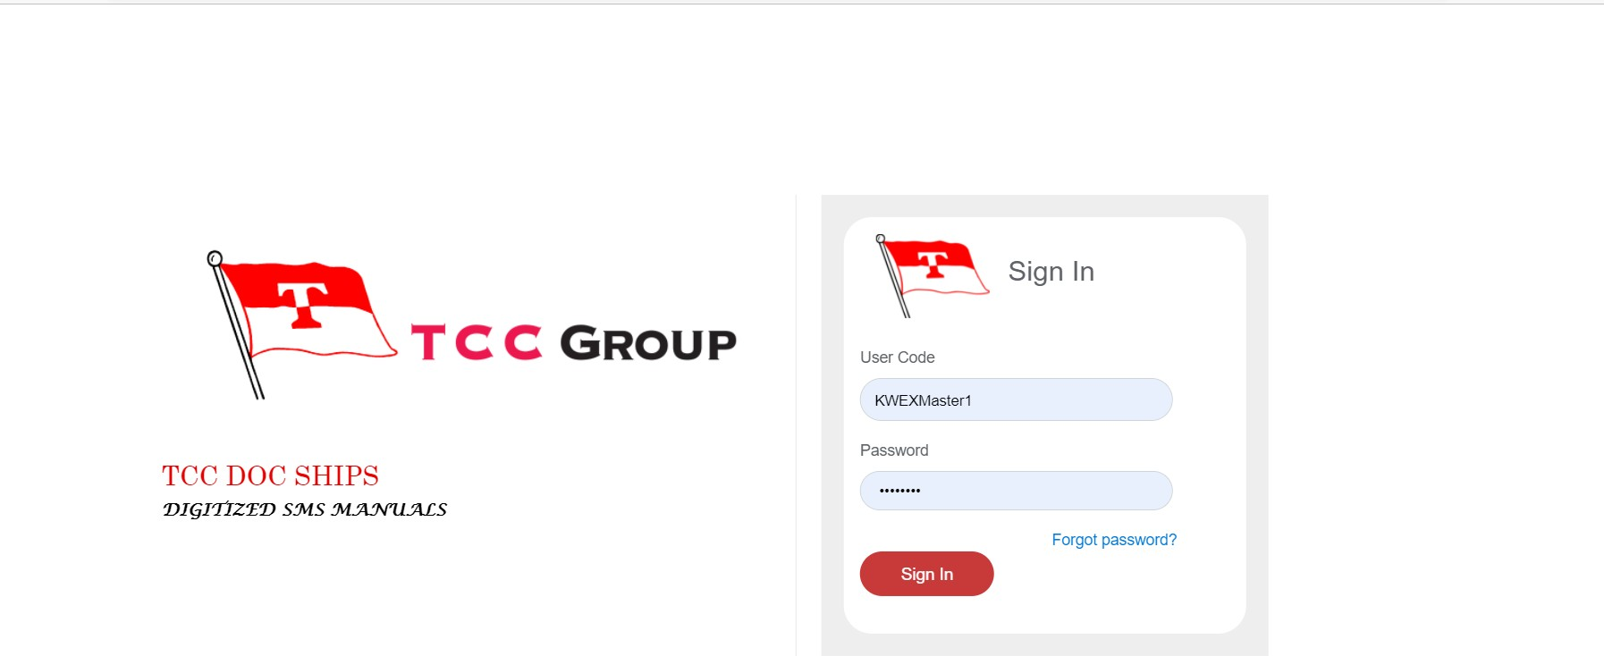

**Click**

**Here**

Fig: Image1

Step 2: Open the application, then go to (VOLUME VIII) **Forms And Checklists** menu and click here.

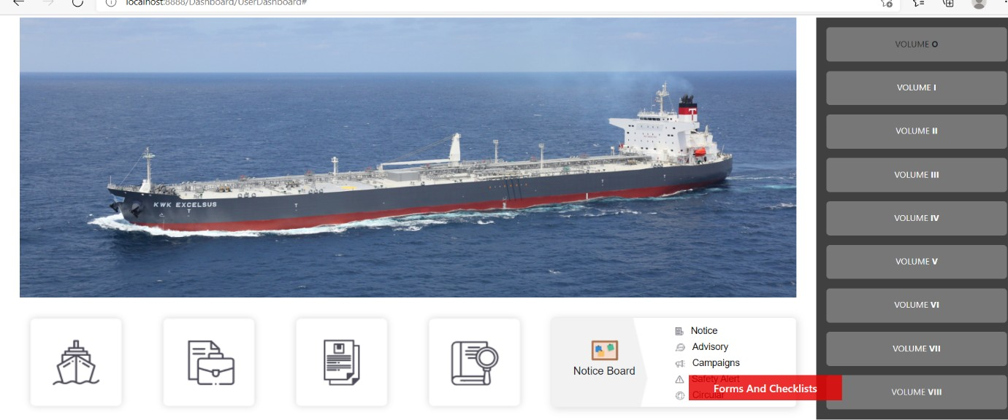

**Click Here**

Fig: Image2

Step 3: When the VOLUME VIII will open then, go to the menu Section1 to Section 6 and click here.

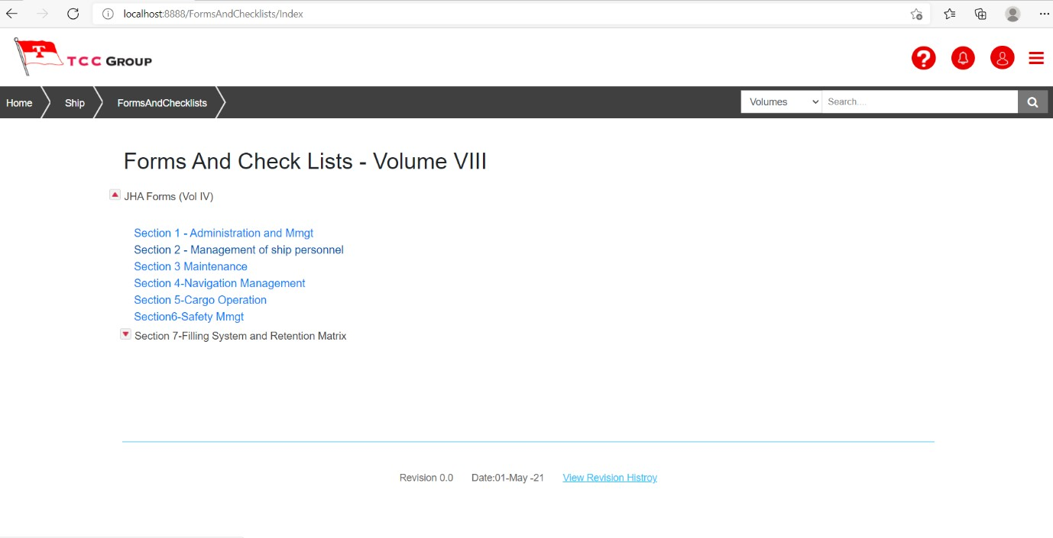

Click

Here

Fig: Image3

Step 4: Click Upload button from the list of Forms and then a window will popup

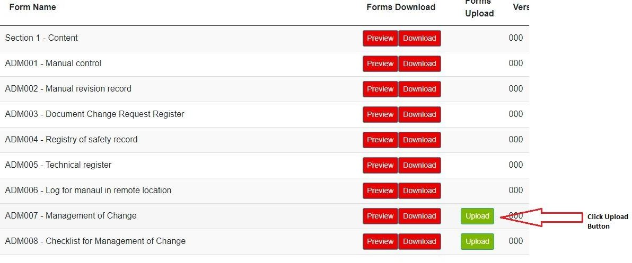

Fig: Image4

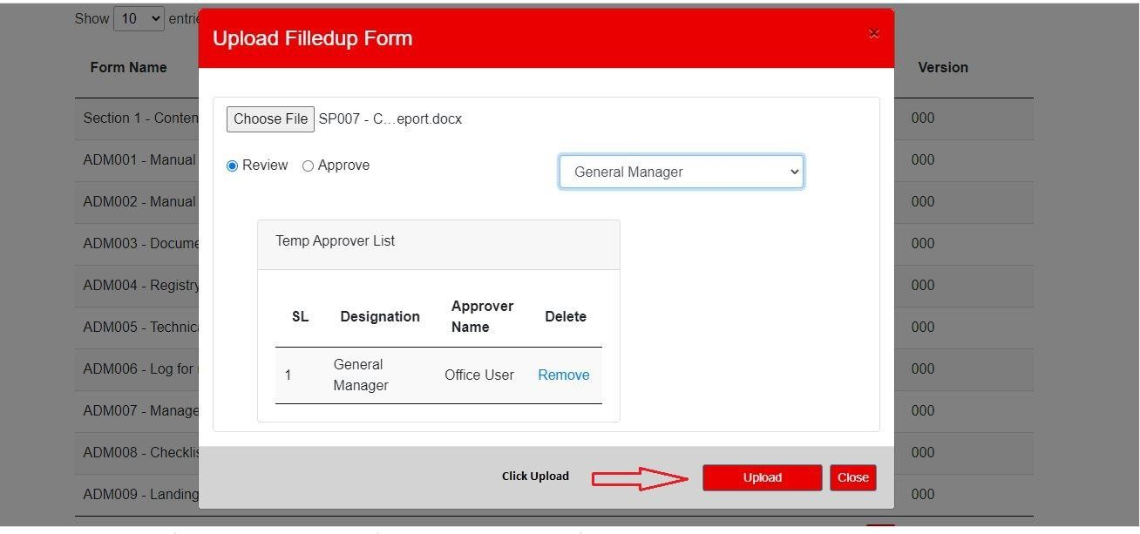

Fig: Image5

Step 5: Choose Specific Form and select Review (radio button) and select Approvers after that Click Upload button. (see above Image5)

**How to Review and / or Approve a form (office)**

**Steps for Form Review (By office)**:-

Step 1: Person whom the form is sent for review or approval will see a notification on bell icon. (Digit denotes no. of forms awaiting review or approval)

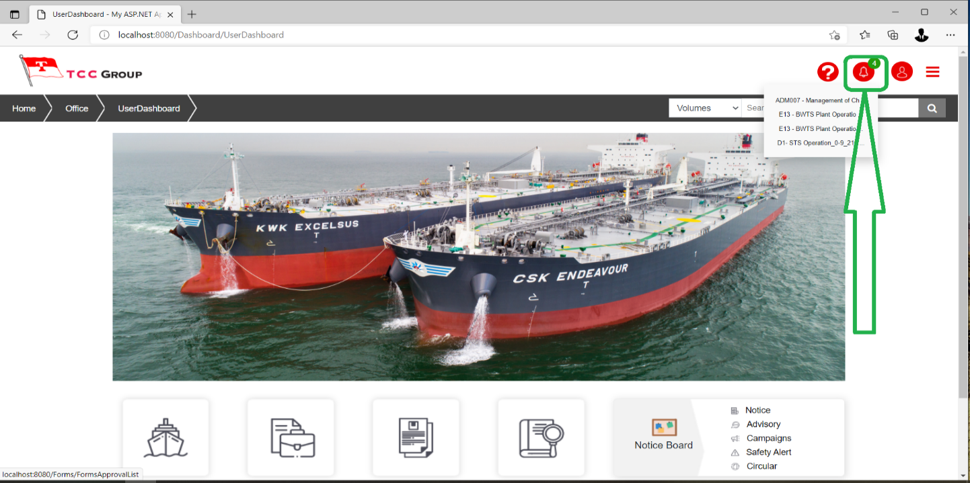

Fig: Image6

Step 2: click on the Notification icon it will take you to Forms Approval List

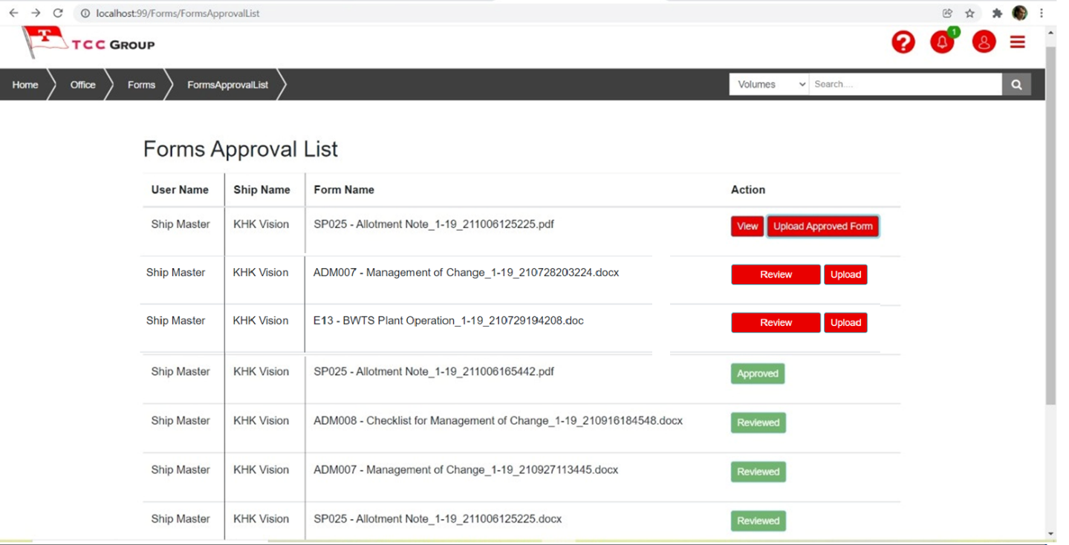

Fig: Image7

Step 3: If the form is for Review a  tab will be there against it and if for approval only Tab will be there

For Review click on the “**Review**” button

Download and review the form

Then click on the “**Upload**” button to upload the same reviewed form

(Don’t Change the name)

Fig: Image8

The vessel will receive the Reviewed form and then download it by click on “download” button of the

Reviewed form. (see below Image)

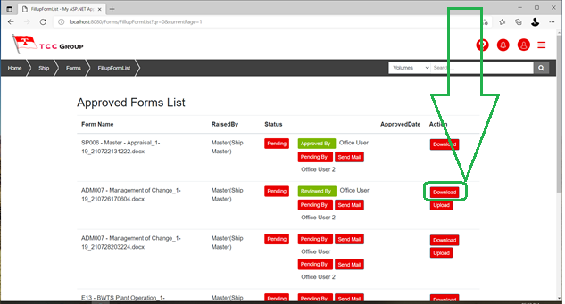

Fig: Image9

Then edit the form and send for approval following the process of sending form for approval.

**Step1:** Go to Approved form List OR Approval pending Forms List (Click Waiting Approval or Approved button see below Image3)

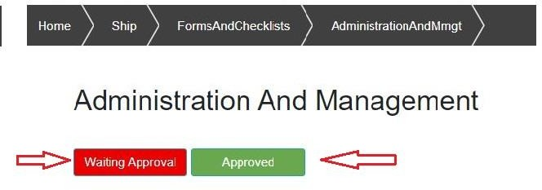

Fig: image10

**Step2:** Click Download button to download the reviewed From and then modify (if required). After that Click Upload button to upload the Modified Reviewed Form (See below Image4).

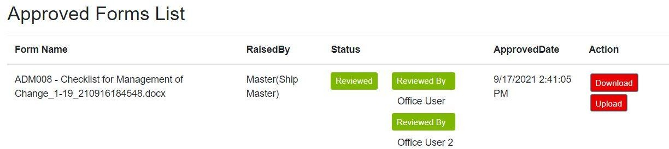

Fig: Image11

**Step3:** Choose The specific Modified Reviewed Form and Select Approvers and the click Upload button to upload for Approval. (see below Image4)

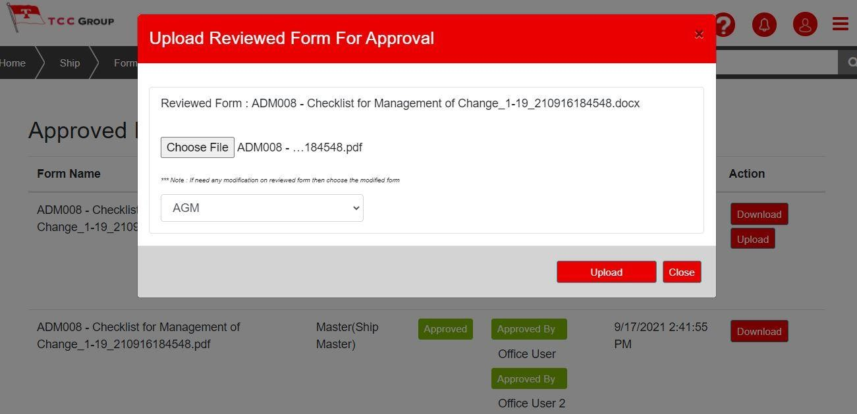

Fig: Image12

**Steps for Form Approval (By office)**:-

Assigned person in office will get notification and email for the approval of the form/forms

Fig: Image13

Click on the notification bell icon. It will take you to the Forms approval list

Click on the View Button

Fig: Image14

Click on the “**View**” button to view the form in pdf.

Check and approve by signing the form.

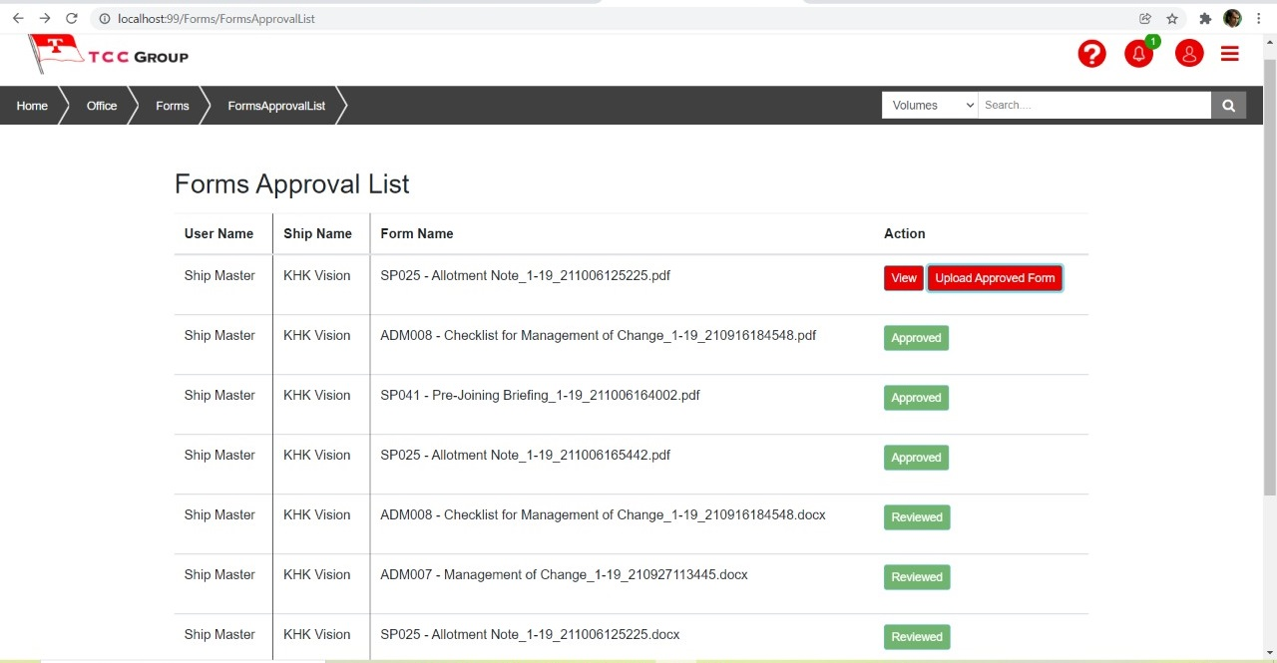

Click Upload Approved Form

Fig: Image15

Then click on the “**Upload Approved Form**” button to upload the approved form. Then choose the reviewed form to upload and click on “Upload” button. (see below Image)

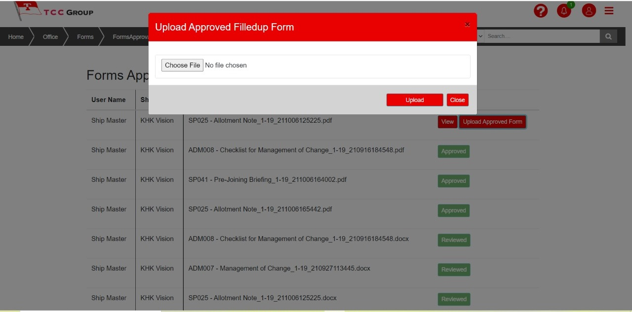

Fig: Image16

Once Uploaded, the uploaded form will be sent to the ship in the next mail exchange.

Screen shot 1. Ship with notification image (should be one ship only not general screen

Screen shot 2. click on approved to download the approved form

## How to Upload Normal Form for Approval (By Ship)?

Step 1: Click Upload button from the list of Forms and then a window will popup



Fig: Image17

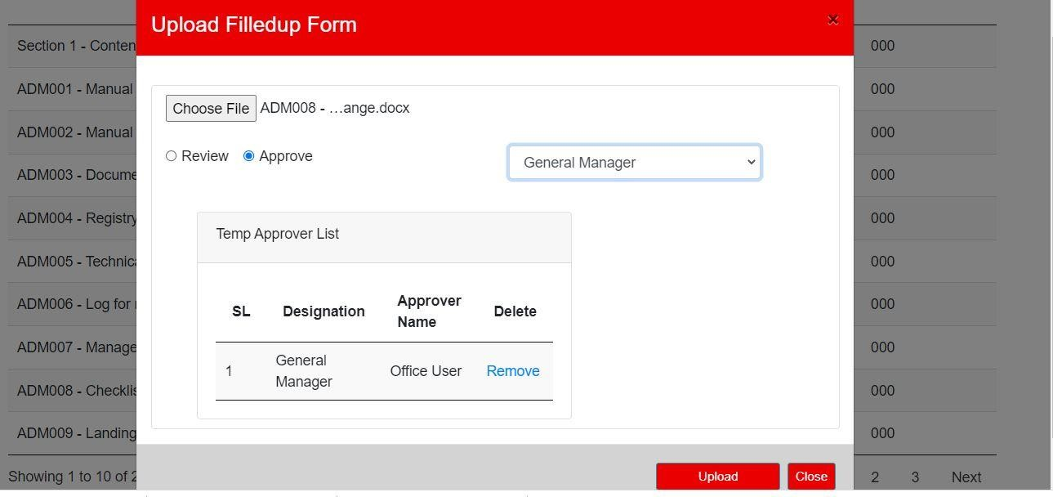

Fig: Image18

Step 2: Choose Specific Form and select Approve (radio button) and select Approvers after that Click Upload button. (see above Image18)

After uploading and Approval, log off, click the log off button.

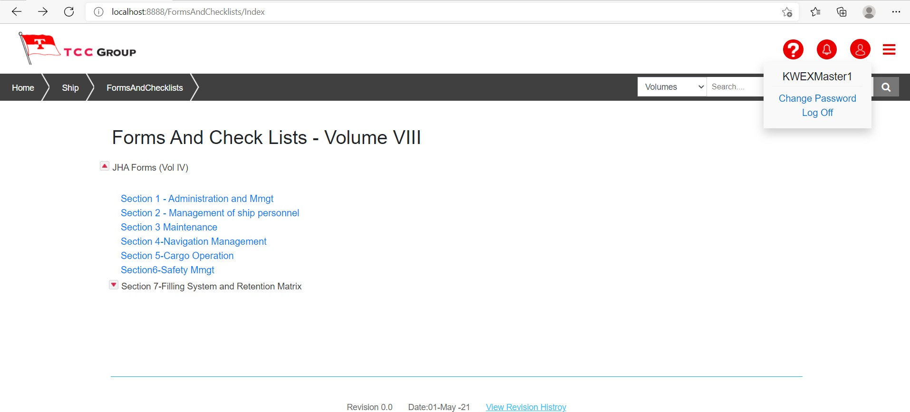

Fig: Image19

Click the **Ok** button for Log Off.

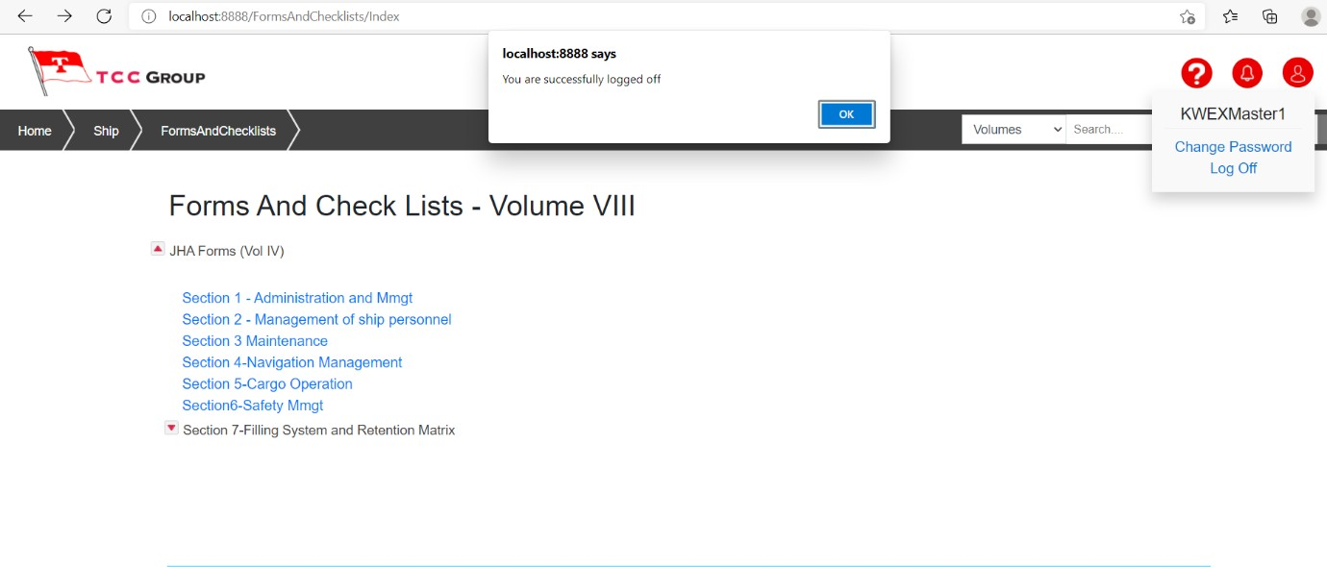

Fig: Image20